Ubuntu EC2 setup and docker installation (2GB RAM + 2vcpu + 20 gb storage)

# update
sudo apt update && sudo apt upgrade -y

# install dependencies
sudo apt install -y ca-certificates curl gnupg lsb-release

# add Docker official GPG and repo
sudo mkdir -p /etc/apt/keyrings
curl -fsSL https://download.docker.com/linux/ubuntu/gpg | sudo gpg --dearmor -o /etc/apt/keyrings/docker.gpg
echo \
"deb [arch=$(dpkg --print-architecture) signed-by=/etc/apt/keyrings/docker.gpg] https://download.docker.com/linux/ubuntu \
$(lsb_release -cs) stable" | sudo tee /etc/apt/sources.list.d/docker.list > /dev/null

sudo apt update
sudo apt install -y docker-ce docker-ce-cli containerd.io docker-buildx-plugin docker-compose-plugin

# add ubuntu user to docker group to avoid sudo for docker
sudo usermod -aG docker ubuntu

# enable & start docker
sudo systemctl enable docker --now

# verify
docker --version
docker compose version

After system installation and docker setup:

mkdir openwebui/
sudo chown ubuntu:ubuntu openwebui/
cd openwebui/
git clone https://github.com/open-webui/open-webui.git .

# Edit docker-compose.otel.yaml file to expose port and add an environment variable ENABLE_OTEL_TRACES=true

vim docker-compose.otel.yaml
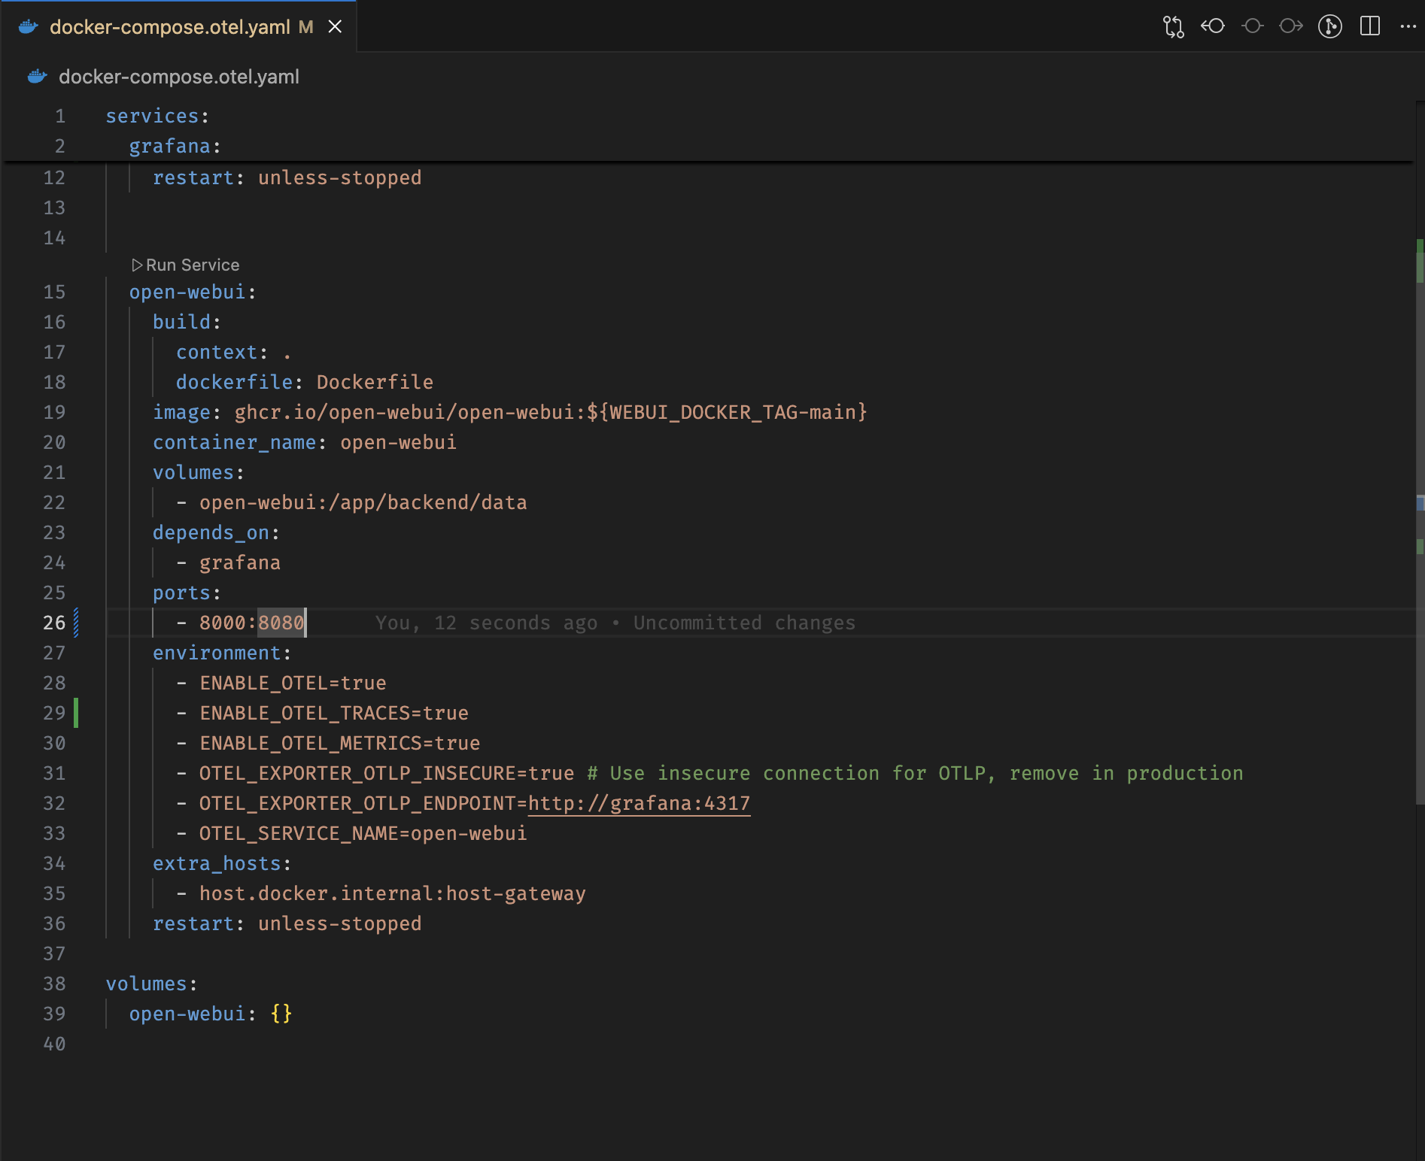
Correct YAML:
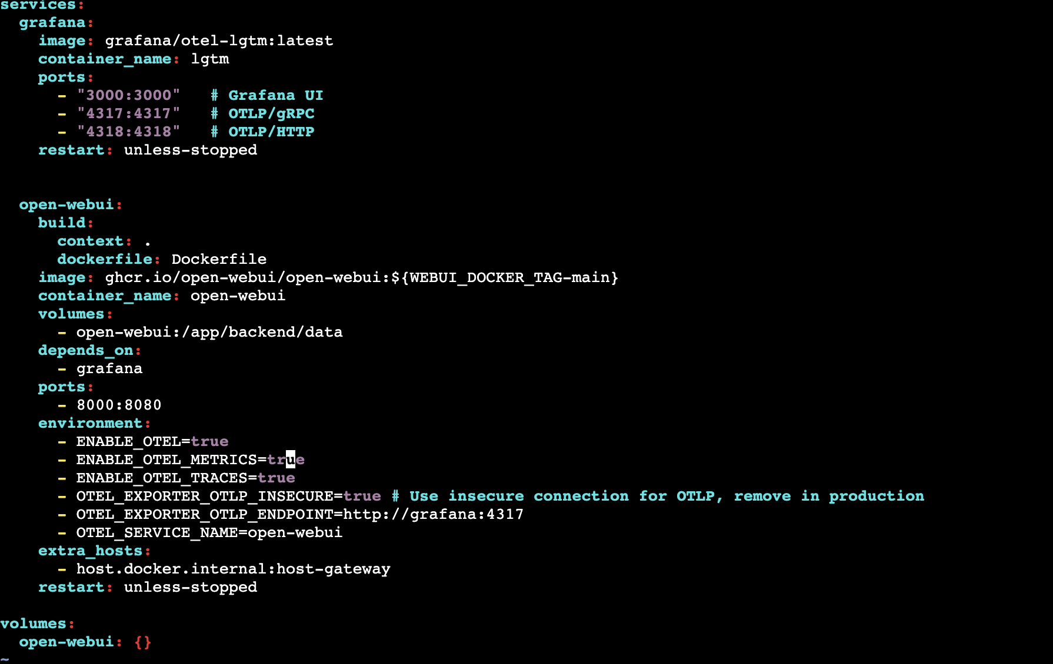
Make one edit for open-webui port
- 8000:8080 (exposing 8000 port for openwebui)
Add environment variable
- ENABLE_OTEL_TRACES=true (to capture server traces)

# RUN openwebui now using docker compose
sudo docker compose -f docker-compose.otel.yaml up -d
After the server is started via docker compose:
MAKE SURE THAT 3000 and 8000 PORT are exposed via AWS SECURITY GROUP
Now the openwebui would be available on the 8000 port
<public_ip/public_url>:8000 -> openwebui
<public_ip/public_ec2>:3000 -> grafana dashboard
Run the server in background
sudo vim /etc/systemd/system/openwebui.service

[Unit]
Description=Open WebUI + Grafana Docker Compose Service
Requires=docker.service
After=docker.service
[Service]
Type=oneshot
WorkingDirectory=/home/ubuntu/openwebui
ExecStart=/usr/bin/docker compose -f docker-compose.otel.yaml up -d
ExecStop=/usr/bin/docker compose -f docker-compose.otel.yaml down
RemainAfterExit=yes
TimeoutStartSec=0
[Install]
WantedBy=multi-user.target

sudo systemctl daemon-reload
sudo systemctl enable --now openwebui.service

sudo systemctl status openwebui.service

